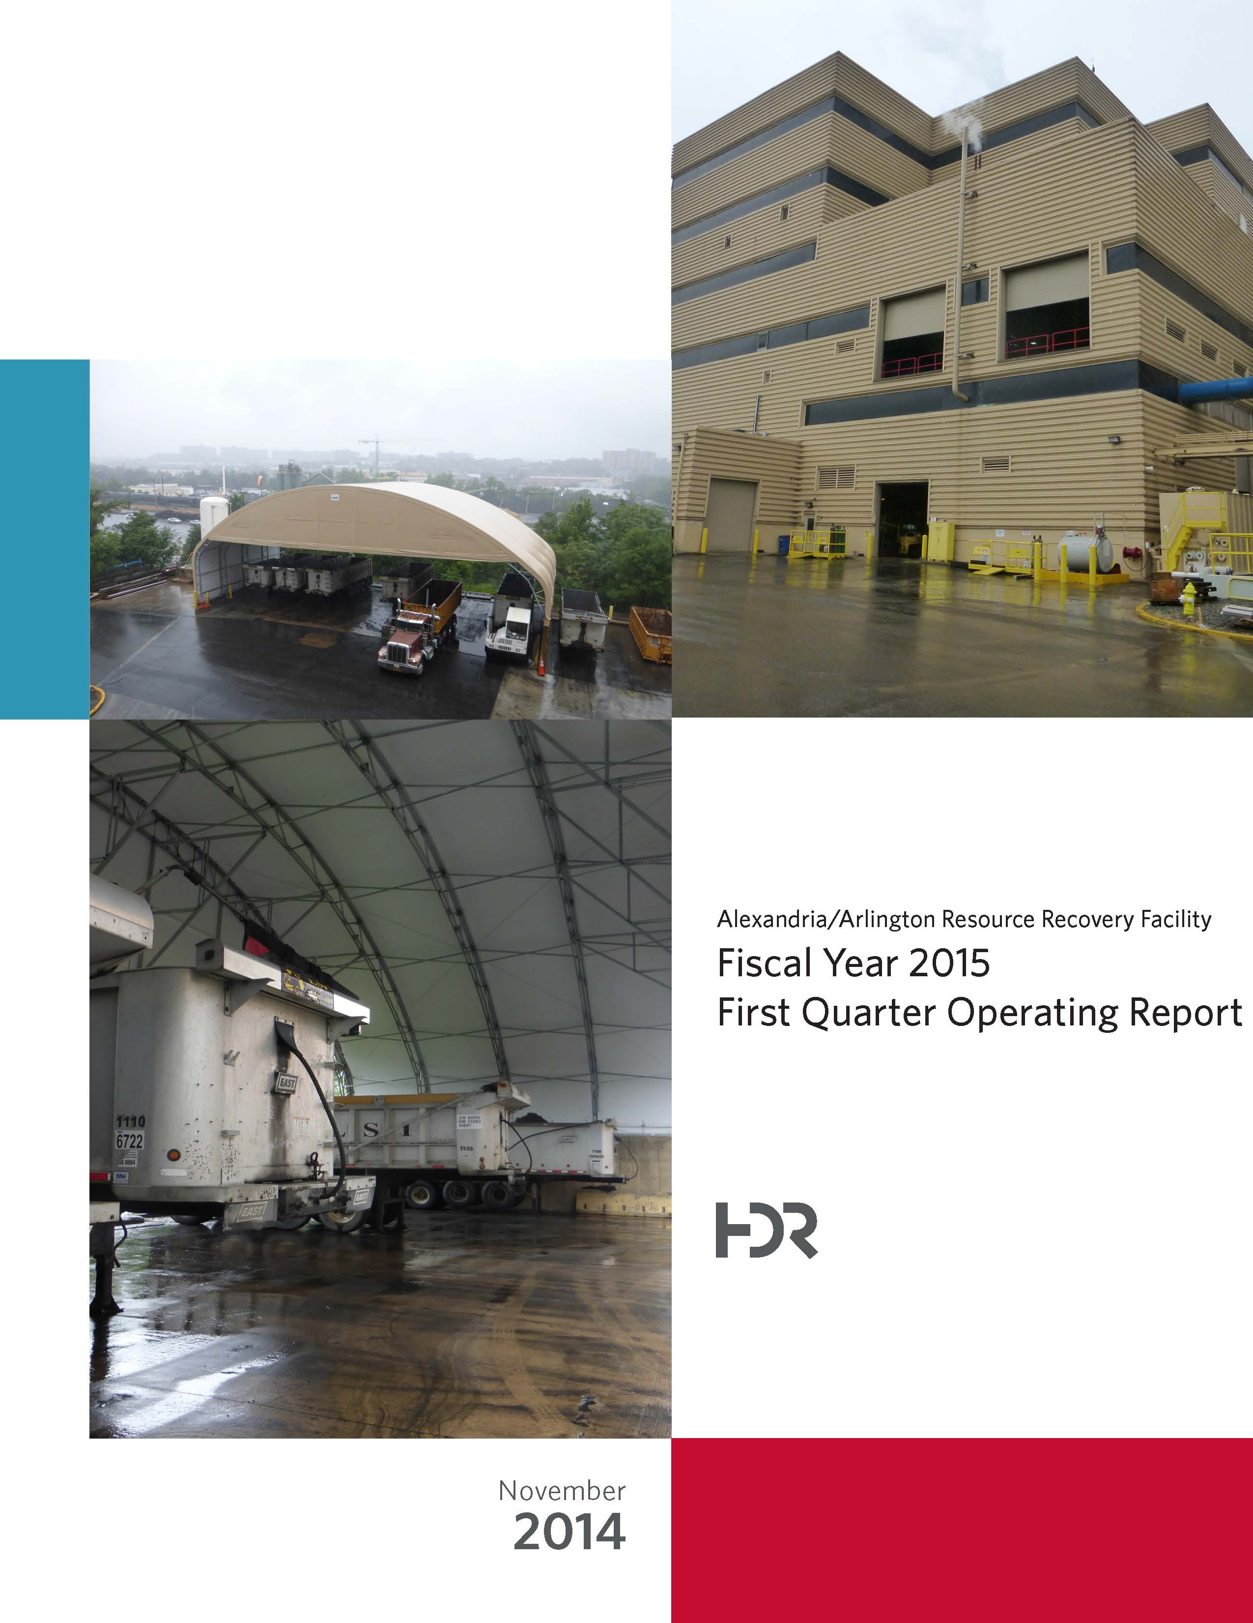

Table of Contents

Section No. Page No.

1.0 Purpose of Report 4

2.0 Executive Summary 4

3.0 Facility Inspection and Records Review 5

4.0 Facility Performance 8

4.1 Utility and Reagent Consumptions 20

4.2 Safety & Environmental Training 21

5.0 Facility Maintenance 23

5.1 Availability 23

5.2 Downtime Summary 24

5.3 Facility Housekeeping 26

6.0 Environmental 27

6.1 Nitrogen Oxide Emissions 27

6.2 Sulfur Dioxide Emissions 27

6.3 Carbon Monoxide Emissions 28

6.4 Opacity 28

6.5 Daily Emissions Data 28

6.6 Ash System Compliance 28

APPENDIX A FACILITY CEMS DATA 31

APPENDIX B PHOTOS 35

List of Tables

Table No. Page No.

Table 1: Summary of Audit Report Deficiencies 7

Table 2: Quarterly Performance Summaries 14

Table 3: Waste Delivery Classification 15

Table 4: Facility Utility and Reagent Consumptions 20

Table 5: Quarterly Facility Unit Availabilities 24

Table 6: Boiler Downtime – Q1FY15 25

Table 7: Turbine Generator Downtime – Q1FY15 25

Table 8: Facility Housekeeping Ratings – August 2014 26

Table 9: Comparison of Statistical Results and Regulatory Thresholds for Metal Analytes 29

Table 10: Unit #1 Monthly Summary for Reportable Emissions Data 32

Table 11: Unit #2 Monthly Summary for Reportable Emissions Data 33

Table 12: Unit #3 Monthly Summary for Reportable Emissions Data 34

List of Charts

Chart No. Page No.

Chart 1: Tons of Waste Processed 8

Chart 2: Tons of Ash Produced per Ton of Waste Processed 9

Chart 3: Ferrous Recovery Rate 10

Chart 4: Steam Production 11

Chart 5: 12-Month Rolling Steam Production 11

Chart 6: Steam Production Rate 12

Chart 7: Calculated Waste Heating Value 13

Chart 8: Cumulative Total Waste Delivery 16

Chart 9: Gross Electrical Generation 16

Chart 10: Gross Conversion Rate 17

Chart 11: Net Conversion Rate 18

Chart 12: Net Conversion Rate 18

Chart 13: Gross Turbine Generator Conversion Rate 19

Chart 14: Net Turbine Generator Conversion Rate 20

Chart 15: Ash Toxicity Characteristic Leaching Procedure (TCLP) Results 29

Chart 16: Quarterly Ash Test Results 30

List of Figures

Figure No. Page No.

Figure 1: Turbine Generator Enclosure Roof Leaking (3 Locations Observed) – New Deficiency 36

Figure 2: Corrosion on ceiling panels in Turbine Generator Enclosure – New Deficiency 36

Figure 3: Corrosion on ceiling panels in Turbine Generator Enclosure (Alternate Location) 36

Figure 4: Damaged Tipping Floor wall panels – Rainwater running from outside to inside – New Deficiency 36

Figure 5: Tipping Floor Enclosure roof leaking at truck entrance – New Deficiency 36

Figure 6: Tire supporting PVC drain pipe at Tipping Floor Entrance – New Deficiency 36

Figure 7: Exterior siding discolored outside Charging Floor louver above Administration Entrance – New Deficiency 37

Figure 8: New Ash Trailer Canopy – View from SDA Penthouse 37

Figure 9: Dolomitic Lime Silo 37

Figure 10: MSW Pit – View from south end of Charging Floor 37

Figure 11: Turbine Generators 37

Figure 12: New Ash Trailer Canopy – View from Turbine Generator Deck 37

Figure 13: Firing Aisle – Painting In Progress 38

Figure 14: Ferrous Magnet – No Issues Observed 38

Figure 15: Main Vibrating Conveyor – No Issues Observed 38

Figure 16: Ash Load-Out Ramp – No Issues Observed 38

Figure 17: Supplemental Load-Out Dock 38

Figure 18: Truck Scales – No Issues Observed 38

Figure 19: Entrance road degradation – Citizen’s Drop-off Area 39

Figure 20: Citizen’s Drop-off Roll-Off 39

Figure 21: General Facility View – View from Southwest Corner of Property 39

Figure 22: General Facility View – View From Across Eisenhower Avenue 39

Figure 23: General Facility View – View from south side of Cooling Towers 39

Figure 24: Protective Bollards and Anchor System to New Ash Trailer Canopy 39

**Definition of Abbreviations & Acronyms**

|  |  |
| --- | --- |
| Abbreviation/Acronym | Definition |
| APC | Air Pollution Control |
| Apr | April |
| Aug | August |
| Avg | Average |
| Btu | British thermal unit |
| CAAI | Covanta Alexandria Arlington, Inc. |
| CEMS | Continuous Emissions Monitoring System |
| CO | Carbon Monoxide |
| Dec | December |
| Feb | February |
| FMG | Facility Monitoring Group |
| FY | Fiscal Year |
| gal | Gallon |
| GAT | Guaranteed Annual Tonnage |
| HCl | Hydrochloric (Hydrogen Chlorides) |
| HDR | HDR Engineering Inc |
| ID | Induced Draft |
| Jan | January |
| Jul | July |
| Jun | June |
| klbs | Kilo-pounds (1,000 lbs) |
| kWhr | Kilowatt hours (1,000 watt-hours) |
| lbs | Pounds |
| LOA | Letter of Agreement |
| Mar | March |
| Max | Maximum |
| May | May |
| Min | Minimum |
| MSW | Municipal Solid Waste |
| MWhr | Megawatt hours |
| No | Number |
| NOV | Notice of Violation |
| Nov | November |
| NOx | Nitrogen Oxide |
| Oct | October |
| OSHA | Occupational Safety and Health Administration |
| PDS | Potomac Disposal Services |
| ppm | Parts per million |
| ppmdv | Parts per million dry volume |
| PSD | Prevention of Significant Deterioration |
| Q1 | First Quarter |
| Q2 | Second Quarter |
| Q3 | Third Quarter |
| Q4 | Fourth Quarter |
| RE | Reportable Exempt |
| RNE | Reportable Non-Exempt |
| SDA | Spray Dryer Absorber |
| Sep | September |
| SO2 | Sulfur Dioxide |
| TCLP | Toxicity Characteristic Leaching Procedure |
| VADEQ | Virginia Department of Environmental Quality |
| WL | Warning Letter |
| yr | Year |
| YTD | Year to date |

Alexandria/Arlington Waste-to-Energy Facility

First Quarter Operating Report – Fiscal Year 2015

# Purpose of Report

HDR Engineering, Inc. (HDR) was given authorization by the Facility Monitoring Group (FMG) to conduct quarterly inspections and provide quarterly monitoring reports regarding the operation and maintenance of the Covanta Alexandria/Arlington Waste-to-Energy Facility (Facility) for the 2014 calendar year. This report is prepared for the first quarter of the 2015 fiscal year and summarizes Facility operations between July 1, 2014 and September 30, 2014. This report identifies the fiscal year beginning on July 1, 2014 as FY15 and the quarter beginning on July 1, 2014 as Q1FY15.

This report is based upon the experience HDR has in the waste-to-energy industry, upon site observation visits and previous reports provided by HDR, and upon data provided by Covanta Alexandria / Arlington, Inc. (CAAI), the Facility owner and operator.

# Executive Summary

CAAI operated the Facility in an acceptable manner and in accordance with established waste-to-energy industry practices during Q1FY15. The operation of the Facility, maintenance, safety, and overall cleanliness continue to be above average. Environmental performance was excellent with no reportable environmental excursions throughout the quarter.

During Q1FY15, the Facility experienced four (4) instances of unscheduled downtime for the boilers totaling 109.1 hours, and no unscheduled downtime for the turbine generators. Beginning September 20, 2014, Boiler No. 1 experienced 109. 5 hours of downtime for scheduled maintenance. The boilers experienced six (6) instances of standby time totaling 204.1 hours, and no standby time was experienced by the turbine generators during the quarter. A detailed listing of downtime is provided in Section 5.2 of this report.

Average waste processed during the quarter was 952.8 tons per day, or 97.7% of nominal facility capacity. Waste deliveries averaged 955.5 tons per day, which is 0.3% higher than the burn rate. The capacity utilization of 97.7% compares favorably to industry averages, which are generally in the 88% to 92% range.

Performance trends for various measurements are presented in Section 4. In general, the Facility continues to demonstrate reasonable consistency in month to month performance throughout the most recent three year period tracked for detailed comparisons.

During the quarter, MSW processed increased 0.9% from the corresponding quarter in FY14; steam production increased 1.9%, and electricity generated (gross) increased 2.6% from the corresponding quarter in FY14. The increase in steam generation was largely attributable to the increase (0.4%) in the calculated average waste heating value, offset by more (11.4 additional hours) scheduled, unscheduled, and standby downtime experienced by the boilers. The increase in gross electrical generation in Q1FY15 as compared to Q1FY14 is attributable to the increase in steam production, as well as less (173.8 fewer hours) of scheduled, unscheduled, and standby downtime experienced by the turbine generators.

# Facility Inspection and Records Review

In August 2014, HDR met with the Facility management and other plant personnel to discuss Facility operations and maintenance, acquire Facility data and reports, perform an independent visual inspection of the operating Facility, photograph areas of interest, and perform a review of recent Facility activity. This visit was coordinated with the scheduled FMG Meeting. At the time of the visit, HDR reviewed CAAI records, discussed performance issues with CAAI staff, and provided a verbal report and performance statistics. HDR maintains a running tabulation of the status of corrective actions and plant performance trends. CAAI provides the following documents for each month:

* Facility Monthly Operating Reports
* Monthly Continuous Emissions Monitoring System (CEMS) Reports

Table 1 summarizes maintenance, repair, and plant condition issues reported during this and prior audit reporting periods. An “A” indicates an issue of the highest priority and worthy of immediate attention. Such items are usually safety or operability issues. A “B” indicates that the issue needs to be dealt with as quickly as possible, but is not urgent. These items will usually result in a process improvement or will help avoid future “urgent” issues. A “C” indicates that the issue should be dealt with at the earliest convenience, but is not a priority issue. This category might include issues related to aesthetics, non-urgent maintenance, or housekeeping improvements which are not safety related.

Table 1: Summary of Audit Report Deficiencies

*A is highest priority & demands immediate attention: B needs attention, but is not urgent; C can be addressed at earliest opportunity & is not urgent.

| Item No. | Audit Report Deficiencies | Issue Reported | Priority* | Resolution/Status | Date Resolved | Open / Closed |
| --- | --- | --- | --- | --- | --- | --- |
| 1 | Spider cracking at scale entry area | July 2010 | C | Repair |  | Open |
| 2 | Pothole at truck entry roadway | May 2012 | C | Repair |  | Open |
| 3 | Fire hose not mounted properly at SDA No. 3 Penthouse Access Door | May 2014 | A | Properly stow fire hose | August 2014 | Closed |
| 4 | Personal Protective Equipment locker in APC MCC Electrical Room Empty | May 2014 | A | Stock PPE Locker with proper equipment | August 2014 | Closed |
| 5 | Unused tarp laying over cable trays at Slaker Room No. 1 | May 2014 | A | Remove tarp | August 2014 | Closed |
| 6 | Pothole at Tipping Floor Exit Driveway | May 2014 | C | Repair pothole | August 2014 | Closed |
| 7 | Concrete to roadway drain at truck entrance damaged – exposing reinforcing bar | May 2014 | C | Repair damaged concrete |  | Open |
| 8 | Turbine Generator Enclosure Roof Leaking (3 Locations Observed) - See Figure 1 (Appendix B) | August 2014 | C | Repair roof |  | Open |
| 9 | Corrosion on ceiling panels in Turbine Generator Enclosure – See Figure 2 (Appendix B) | August 2014 | C | Sand, Prime, Paint and Preserve |  | Open |
| 10 | Corrosion on ceiling panels in Turbine Generator Enclosure (Alternate Location) – See Figure 3 (Appendix B) | August 2014 | C | Sand, Prime, Paint and Preserve |  | Open |
| 11 | Damaged Tipping Floor wall panels – Rainwater running from outside to inside – See Figure 4 (Appendix B) | August 2014 | C | Repair damaged Tipping Floor Walls |  | Open |
| 12 | Tipping Floor Enclosure roof leaking at truck entrance – See Figure 5 (Appendix B) | August 2014 | C | Repair roof |  | Open |
| 13 | Tire supporting PVC drain pipe at Tipping Floor Entrance – See Figure 6 (Appendix B) | August 2014 | C | Properly support drain pipe |  | Open |
| 14 | Exterior siding discolored outside Charging Floor louver above Administration Entrance – See Figure 7 (Appendix B) | August 2014 | C | Pressure wash siding around louver |  | Open |

# Facility Performance

Monthly operating data provided by CAAI indicates that 87,659 tons of MSW were processed during Q1FY15, and a total of 87,907 tons of MSW including 756 tons of Special Handling Waste were received. Total ash production during the quarter was 17,751 tons, which represents 20.3% of the waste processed. The average uncorrected steam production rate for Q1FY15 was 3.0 tonssteam/tonwaste, which is 1.0% more than the corresponding quarter in FY14. The increase in this metric is attributable to the increase (0.4%) in the calculated average waste heating value that was experienced during the quarter, as compared to the corresponding quarter in FY14.

Chart 1: Tons of Waste Processed

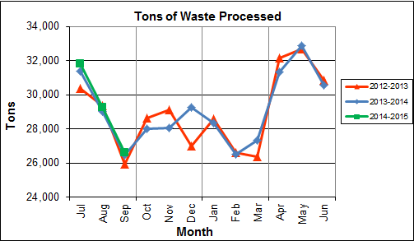

Chart 1 illustrates that Q1FY15 waste processed was slightly higher (0.9%) than the corresponding quarter, Q1FY14.

CAAI reported that 450 tipping floor/MSW internal inspections were conducted during the quarter and CAAI issued five (5) notices of violation (NOVs) for the following:

* July 2014 – Three (3) NOVs were issued for:
  + Dragging trash onto the road
  + Excessive metal in the load
  + Driver hitting the crash bar due to not lowering tailgate before exiting
* August 2014 – One (1) NOV was issued for:
  + Rider on the back of the truck
* September 2014 – One (1) NOV was issued for:
  + Truck leaving the tipping floor with trash on it

Chart 2: Tons of Ash Produced per Ton of Waste Processed

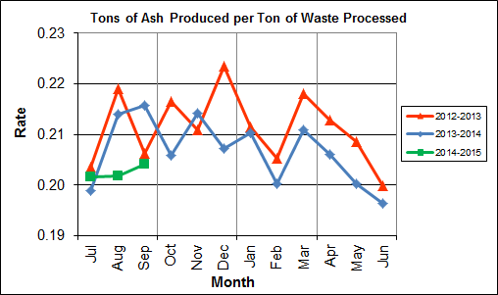

Chart 2 illustrates that ash production rates in Q1FY15 are lower (3.2%) at 20.3% of processed waste, compared to the corresponding quarter in FY14 when the ash production rate was 20.9% of processed waste. The decrease in quarterly ash is attributable to the significant increase (20.7%) in ferrous metal recovery. Ash production remains in the 20.0% to 21.0% range, as a result of the installation of the “semi-dry” ash discharger spray system in May 2012, and represents less moisture in the ash residue shipped to disposal. Another contributing factor is the aforementioned increase in ferrous metal recovery. CAAI installed a new ferrous magnet shell during the latter part of the fall outage season in December 2013 and ferrous metal recovery has been significantly higher in recent months as a result.

Chart 3: Ferrous Recovery Rate

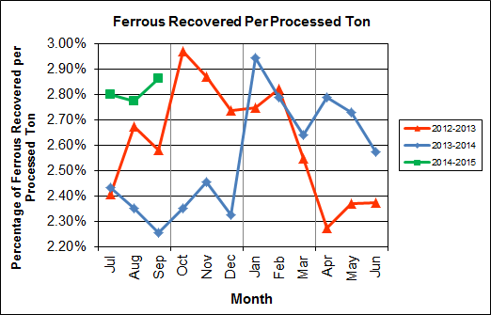

Chart 3 depicts the monthly ferrous metal recovery rate as a percentage of processed MSW tonnage. In Q1FY15, 2,465 tons of ferrous metals were recovered, which is 20.7% higher than the corresponding quarter in FY14 and equivalent to 2.8% of processed waste. The increase in ferrous metal recovery is attributable to the recently installed ferrous magnet shell, which was replaced during an outage in December 2013.

Chart 4: Steam Production

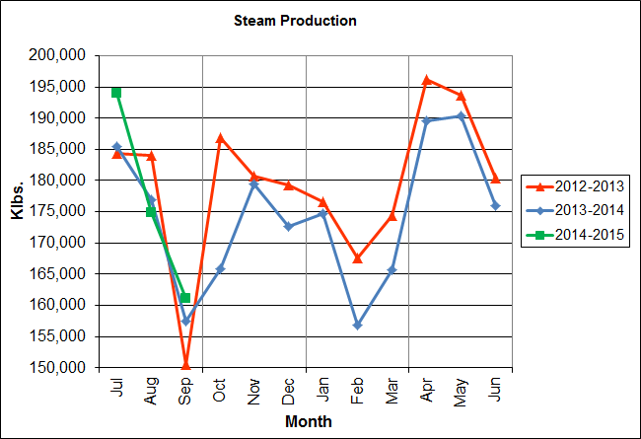

In Chart 4, the total steam production for Q1FY15 was 530,025 klbs., or 1.9% higher than the corresponding quarter in FY14. The increase in steam production is attributable to the higher (0.4%) calculated average waste heating value during the quarter.

Chart 5: 12-Month Rolling Steam Production

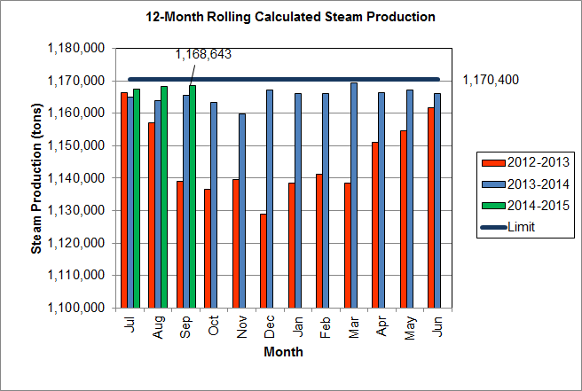

Chart 5 depicts the 12-month rolling steam production total for the period ending in September 2014. According to the Title V permit, the annual steam production for the Facility shall not exceed 1,170,400 tons on the basis of an average value of 3.34 lbs of steam per lb of MSW processed, calculated monthly as the sum of each consecutive 12 month period. The Facility was in compliance with the 12-month rolling steam production total every month in the quarter. The 12-month rolling total for steam production ending in September 2014 was 1,168,643 tons which is 99.8% of the limit.

Chart 6: Steam Production Rate

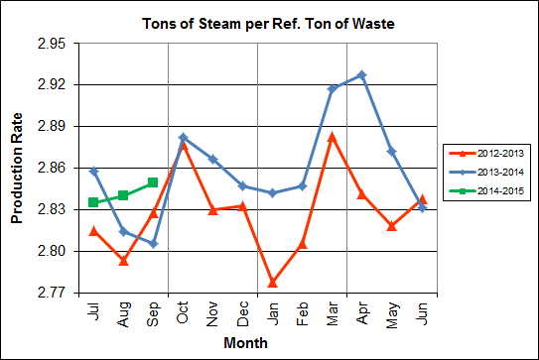

In Chart 6, the conversion of raw waste tonnages into “reference tons” is another way of analyzing steam production, and helps to determine whether changes are related to boiler performance or to fuel issues. “Reference tons” are adjusted to account for the calculated average fuel heating value, so that lower Btu fuel raw tonnages are adjusted upwards and vice versa. In Q1FY15 this metric tracked higher (0.5%), at 2.8 tonssteam/tonref, than the corresponding quarter in FY14.

**Chart 7: Calculated Waste Heating Value**

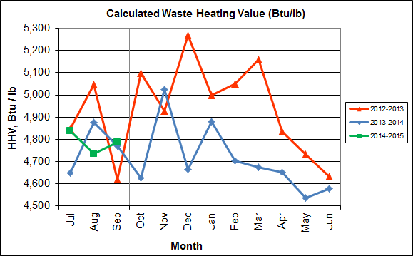

Chart 7 illustrates that Q1FY15 calculated average waste heating value was higher (0.4%) at 4,787 Btu/lb than the corresponding quarter Q1FY14, which averaged 4,766 Btu/lb.

Table 2: Quarterly Performance Summaries

|  |  |  |  |  |  |  |  |  |
| --- | --- | --- | --- | --- | --- | --- | --- | --- |
| Month | | Waste Processed (tons) | Waste Diverted  (tons) | Ash Shipped  (tons) | Special Handling (Supplemental)  (tons) | Ferrous Recovered  (tons) | Steam Produced (klbs) | Net Electrical Generation  (MWhr) |
| **Q1FY13** | **Quarterly Totals** | **85,696** | **0** | **17,970** | **242** | **2,187** | **518,902** | **36,007** |
| July-12 | 30,390 | 0 | 6,185 | 151 | 732 | 184,330 | 13,067 |
| August-12 | 29,376 | 0 | 6,437 | 11 | 786 | 184,057 | 12,978 |
| September-12 | 25,930 | 0 | 5,348 | 80 | 669 | 150,515 | 9,962 |
| **Q1FY14** | **Quarterly Totals** | **86,884** | **0** | **18,167** | **1,470** | **2,043** | **519,971** | **35,635** |
| July-13 | 31,409 | 0 | 6,249 | 546 | 764 | 185,488 | 12,755 |
| August-13 | 29,000 | 0 | 6,206 | 676 | 682 | 176,948 | 12,208 |
| September-13 | 26,475 | 0 | 5,712 | 248 | 597 | 157,535 | 10,672 |
| **Q1FY15** | **Quarterly Totals** | **87,659** | **0** | **17,751** | **756** | **2,465** | **530,025** | **36,806** |
| July-14 | 31,818 | 0 | 6,417 | 141 | 891 | 193,977 | 13,779 |
| August-14 | 29,247 | 0 | 5,904 | 266 | 812 | 174,887 | 12,018 |
| September-14 | 26,594 | 0 | 5,430 | 349 | 762 | 161,161 | 11,009 |
| **FY15 YTD Totals** | | **87,659** | **0** | **17,751** | **756** | **2,465** | **530,025** | **36,806** |
| **FY14 Totals** | | **349,118** | **0** | **72,071** | **3,549** | **8,922** | **2,099,974** | **143,064** |
| **FY13 Totals** | | **347,790** | **0** | **73,446** | **2,665** | **9,063** | **2,154,201** | **148,366** |

Table 2 presents the production data provided to HDR by CAAI for Q1FY15 on both a monthly and quarterly basis. For purposes of comparison, data for Q1FY13 and Q1FY14 are also shown, as well as FY13, FY14 and FY15 year to date totals.

In comparing quarterly totals, the data shows:

* More waste was processed in Q1FY15 than Q1FY14 and Q1FY13
* More steam was generated in Q1FY15 than Q1FY14 and Q1FY13
* More electricity was generated in Q1FY15 than Q1FY14 and Q1FY13
* Less supplemental waste was received in Q1FY15 than Q1FY14 and more than Q1FY13.

Please note that the total steam generation figures presented in Table 2 do not correlate with the annual steam production limit from the Facility Permit; such limits apply on a 12-month rolling average monthly basis, and not a fiscal year basis. It is also worth noting that the quantity of waste processed during Q1FY15 and FY15 continues to be limited by the steam production permit restrictions (refer to Chart 5).

Table 3: Waste Delivery Classification

|  |  |  |  |  |  |  |  |  |  |  |  |  |  |  |  |
| --- | --- | --- | --- | --- | --- | --- | --- | --- | --- | --- | --- | --- | --- | --- | --- |
|  |  | **Jul** | **Aug** | **Sep** | **Oct** | **Nov** | **Dec** | **Jan** | **Feb** | **Mar** | **Apr** | **May** | **Jun** | **Totals** | **% of Total** |
| **FY11** | **Jurisdiction Waste** | 18,201 | 19,320 | 18,100 | 18,244 | 17,812 | 17,394 | 16,316 | 15,212 | 18,279 | 18,596 | 20,355 | 19,382 | 217,213 | 62.20% |
| **Spot Waste tons** | 13,996 | 13,917 | 11,696 | 9,336 | 10,177 | 11,441 | 12,968 | 7,016 | 8,459 | 10,177 | 12,947 | 9,657 | 131,786 | 37.74% |
| **Supplemental Waste** | 8 | 17 | 12 | 13 | 6 | 13 | 14 | 34 | 25 | 29 | 26 | 6 | 203 | 0.06% |
| **MSW Totals** | **32,205** | **33,254** | **29,808** | **27,593** | **27,995** | **28,848** | **29,298** | **22,262** | **26,763** | **28,803** | **33,328** | **29,044** | **349,202** | **100.00%** |
|  |  |  |  |  |  |  |  |  |  |  |  |  |  |  |  |
| **FY12** | **Jurisdiction Waste** | 18,112 | 20,021 | 19,304 | 17,796 | 17,523 | 17,211 | 16,202 | 14,952 | 17,430 | 18,338 | 20,138 | 18,361 | 215,381 | 61.89% |
| **Spot Waste tons** | 8,901 | 13,623 | 13,303 | 9,788 | 11,976 | 11,900 | 10,276 | 10,697 | 10,283 | 10,029 | 11,333 | 10,177 | 132,295 | 38.01% |
| **Supplemental Waste** | 10 | 10 | 34 | 15 | 15 | 21 | 12 | 22 | 15 | 23 | 68 | 91 | 336 | 0.10% |
| **MSW Totals** | **27,023** | **33,654** | **32,641** | **27,599** | **29,514** | **29,132** | **26,490** | **25,672** | **27,729** | **28,390** | **31,539** | **28,629** | **348,012** | **100.00%** |
|  |  |  |  |  |  |  |  |  |  |  |  |  |  |  |  |
| **FY13** | **Jurisdiction Waste** | 19,413 | 18,357 | 16,632 | 17,625( | 18,838 | 16,195 | **-** | **-** | **-** | **-** | **-** | **-** | 107,058 | 30.76% |
| **Spot Waste tons** | 10,516 | 11,326 | 10,610 | 10,317 | 9,330 | 9,558 | **-** | **-** | **-** | **-** | **-** | **-** | 61,656 | 17.72% |
| **City Waste** | **-** | **-** | **-** | **-** | **-** | **-** | 1,683(1) | 1,287 | 1,444 | 2,382 | 2,286 | 1,919 | 11,000 | 3.16% |
| **County Waste** | **-** | **-** | **-** | **-** | **-** | **-** | 2,442(1) | 2,100 | 2,372 | 3,381 | 3,932 | 3,309 | 17,536 | 5.04% |
| **Municipal Solid Waste** | **-** | **-** | **-** | **-** | **-** | **-** | 25,019(1) | 23,637 | 21,661 | 27,066 | 25,794 | 24,930 | 148,107 | 42.56% |
| **Supplemental Waste** | 151 | 11 | 80 | 25 | 234 | 405 | 363 | 365 | 76 | 403 | 281 | 271 | 2,665 | 0.77% |
| **MSW Totals** | **29,928** | **29,683** | **27,241** | **27,942** | **28,167** | **25,753** | **29,507** | **27,388** | **25,552** | **33,231** | **32,293** | **30,429** | **348,022** | **100.00%** |
|  |  |  |  |  |  |  |  |  |  |  |  |  |  |  |  |
| **FY14** | **City Waste** | 2,065 | 1,693 | 1,702 | 1,924 | 1,566 | 1,780 | 1,529 | 1,231 | 1,556 | 2,256 | 2,203 | 1,883 | 21,389 | 6.11% |
| **County Waste** | 3,459 | 3,079 | 2,784 | 3,091 | 2,707 | 2,802 | 2,568 | 1,957 | 2,272 | 3,326 | 3,987 | 3,387 | 35,419 | 10.12% |
| **Municipal Solid Waste** | 26,167 | 23,604 | 22,034 | 23,354 | 21,879 | 25,531 | 23,869 | 22,523 | 23,198 | 25,414 | 27,206 | 24,812 | 289,590 | 82.75% |
| **Supplemental Waste** | 546 | 676 | 248 | 410 | 188 | 268 | 275 | 192 | 231 | 253 | 151 | 110 | 3,548 | 1.01% |
| **MSW Totals** | **32,237** | **29,053** | **26,768** | **28,779** | **26,340** | **30,380** | **28,241** | **25,903** | **27,256** | **31,249** | **33,546** | **30,193** | **349,946** | **100.00%** |
|  |  |  |  |  |  |  |  |  |  |  |  |  |  |  |  |
| **FY15** | **City Waste** | 1,814 | 1,497 | 1,699 |  |  |  |  |  |  |  |  |  | 5,009(2( | 5.70% |
| **County Waste** | 3,297 | 2,868 | 2,973 |  |  |  |  |  |  |  |  |  | 9,137(2) | 10.39% |
| **Municipal Solid Waste** | 26,661 | 24,466 | 21,887 |  |  |  |  |  |  |  |  |  | 73,014(2) | 83.06% |
| **Supplemental Waste** | 141 | 275 | 329 |  |  |  |  |  |  |  |  |  | 745(2) | 0.85% |
| **MSW Totals** | **31,913** | **29,106** | **26,888** |  |  |  |  |  |  |  |  |  | **87,907(2)** | **100.00%** |
| **Note (1): Beginning January 2013, the method in which waste was classified was modified as compared to prior periods due to change in contractual obligations and plant ownership**  **Note (2): Totals are Year to Date (YTD) Values** | | | | | | | | | | | | | | | |

Chart 8: Cumulative Total Waste Delivery

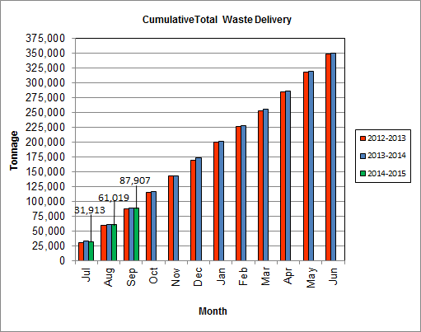

As Depicted in Table 3 and Chart 8, for the period ending in September 2014; cumulative total waste delivery was 0.2% less compared to the same period in FY14.

Chart 9: Gross Electrical Generation

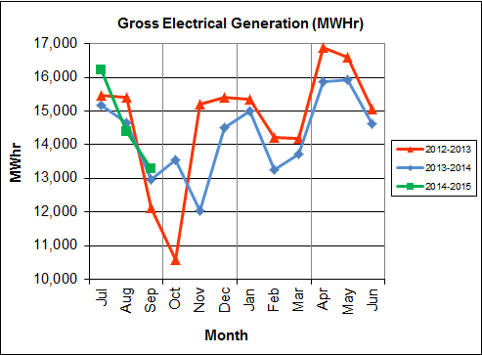

During Q1FY15, the Facility generated 43,891 MWhrs (gross) of electricity compared to Q1FY14 generation of 42,797 MWhrs (gross), a 2.6% increase. The increase in gross electrical production is attributable to the increase (1.9%) in steam production and less (173.8 fewer hours) scheduled, unscheduled, and standby downtime.

Note that the 3-year low of gross electrical production experienced in October 2012 was due to Turbine Generator No. 1 experiencing 494.5 hours of downtime for scheduled maintenance and again in November 2013 when Turbine Generator No. 2 had a major overhaul and experienced 494.8 hours of downtime. Evidence of the downtime experienced by the Turbine Generators is also apparent in Chart Nos. 10 through 14, including sharp spikes in the trends for the months of October 2012 and November 2013 when the Overhauls were conducted on Turbine Generator Nos. 1 and 2, respectively.

Chart 10: Gross Conversion Rate

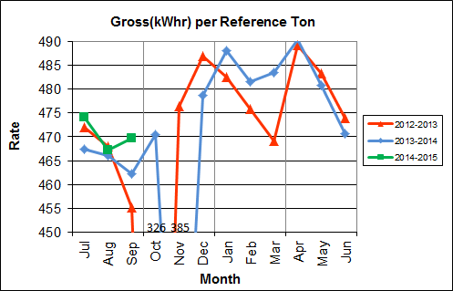

As shown in Chart 10, the average gross electrical generation per reference ton of refuse processed during Q1FY15 was 470 kWhr, which is 1.1% higher than the corresponding quarter in FY14. Since this calculated value uses reference or normalized tonnages of waste, it should cancel the effect of MSW heating value (Btu content) variability.

Chart 11: Net Conversion Rate

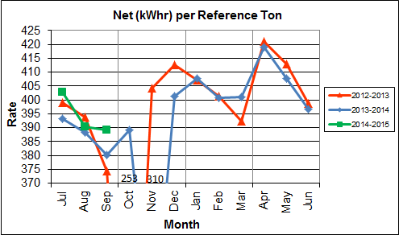

Chart 11 depicts the normalized net power (gross minus in-house usage) generation history. In Q1FY15, the average net electrical generation per reference ton was 394 kWhr, which is 1.8% higher than the corresponding quarter in FY14.

Chart 12: Net Conversion Rate

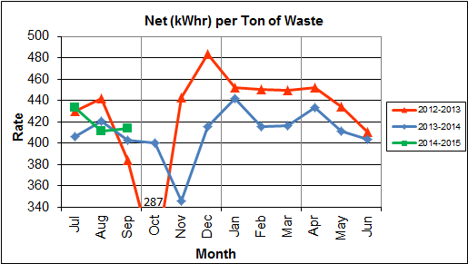

Chart 12 depicts the net power generation per processed ton. The net electrical generation per processed ton in Q1FY15 was 419 kWhr, which is 2.3% higher than the corresponding quarter in FY14.

Chart 13: Gross Turbine Generator Conversion Rate

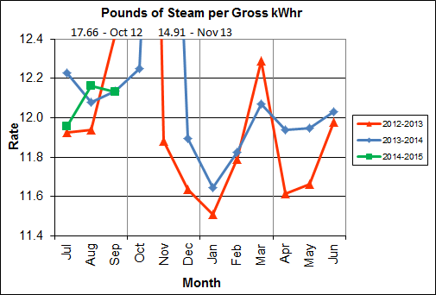

Charts 13 and 14 illustrate the quantities of steam required to generate one kWhr of electricity, gross and net respectively. This measure is a turbine generator performance indicator, where lower steam rates indicate superior performance. For simplification, this calculated rate is based on the average for the two turbine generators. In Q1FY15 the average lbs of steam consumed per gross kWhr was 12.1, which is lower (0.6%) than the corresponding quarter Q1FY14, and indicative of slightly improved turbine generator performance. The average lbs of steam consumed per net kWhr was 14.4, which is lower (1.3%) than the corresponding quarter in FY14. The average steam temperature during the quarter was 684.2° F, which is 1.3% lower than the average steam temperature of the corresponding quarter last year and 15.8° F lower than design temperature of 700o F.

CAAI reported that during the Turbine Generator No. 2 overhaul in November 2013, some cracking was observed on the Stage 9 blades of the rotor, and the blading in that row was removed as a precautionary measure. CAAI indicated that a new set of blades will be manufactured and installed during a Turbine Generator No. 2 Outage in 2016.

Chart 14: Net Turbine Generator Conversion Rate

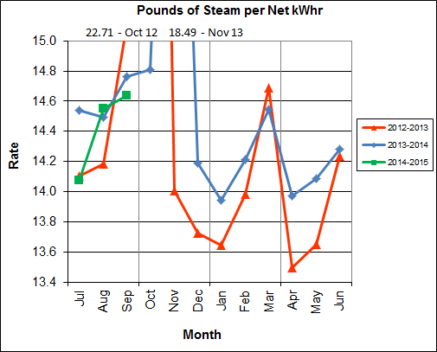

## Utility and Reagent Consumptions

Table 4: Facility Utility and Reagent Consumptions

|  |  |  |  |  |  |
| --- | --- | --- | --- | --- | --- |
| **Utility** | **Units** | **Q1FY15 Total** | **Q1FY14**  **Total** | **Q1FY15”Per Processed Ton” Consumption** | **Q1FY14”Per Processed Ton” Consumption** |
| **Purchased Power** | MWhr | 5,549 | 5,664 | 0.06 | 0.07 |
| **Fuel Oil** | Gal. | 7,660 | 12,000 | 0.09 | 0.14 |
| **Boiler Make-up** | Gal. | 2,459,000 | 2,195,000 | 28.05 | 25.26 |
| **Cooling Tower Make-up** | Gal. | 40,727,344 | 39,639,291 | 464.61 | 456.23 |
| **Pebble Lime** | Lbs. | 1,182,000 | 1,226,000 | 13.48 | 14.11 |
| **Ammonia** | Lbs. | 172,000 | 157,000 | 1.96 | 1.81 |
| **Carbon** | Lbs. | 104,000 | 104,000 | 1.19 | 1.20 |
| **Dolomitic Lime** | Lbs. | 264,000 | 382,000 | 3.01 | 4.40 |

Fuel oil usage during the quarter represents approximately 0.13% of the total heat input to the boilers, which compares favorably with industry averages, and lower than the percentage of heat input in Q1FY14 which was 0.21%. Fuel oil is used to stabilize combustion of wet fuel, as well as during start-up and shut-down of the boilers for maintenance. Boiler makeup water usage during the quarter represents 3.9% of steam flow, and is acceptable. Pebble lime usage, at 1,182,000 lbs. is lower (3.6%) than the corresponding quarter last year, and the quarterly consumption rate of 13.5 lbs/ton is below historical levels (16-18 lbs/ton).

In comparing Q1FY15 to Q1FY14 on a per processed ton consumption basis:

* the purchased power consumption rate was 2.9% lower
* the total fuel oil consumption rate was 36.7% lower
* the boiler make-up water consumption rate was 11.0% higher
* the cooling tower make-up water consumption rate was 1.8% higher
* the total pebble lime consumption rate was 4.4% lower
* the ammonia consumption rate was 8.6% higher
* the carbon consumption rate was 0.9% lower
* the total dolomitic lime consumption rate was 31.5% lower

## Safety & Environmental Training

The Facility had no recordable accidents during the quarter and has operated 1,412 days without an OSHA recordable incident through the end of September 2014. Safety and Environmental training was conducted during the quarter with themes as follows:

**July 2014**

* Safety:
  + Outages and Hazard Recognition
  + Shared Accountability – Contractors
  + Lock-out Tag-out – Group and Personal
* Environmental:
  + Regulatory Requirements
  + Recordkeeping
  + Reporting and Walk-downs

**August 2014**

* Safety:
  + Electrical Safety Awareness
  + OSHA – Employee Engagement and Rights
  + VPP Requirements
  + Personal Protective Equipment (PPE)
  + Corrosives and Bulk Chemical Unloading
* Environmental:
  + Stack Testing

**September 2014**

* Safety:
  + Behavior Based Safety
  + Ergonomics
  + Pushing Vs. Pulling Techniques
  + Electrical Safe Body Positioning
* Environmental:
  + Air Quality Upsets

In July 2014 CAAI reports that it received an Industry Leader Award from the National Safety Council (NSC). The NSC awarded 46 organizations the NSC 2014 Industry Leader Award for safety performance in their industries. The Industry Leader Award is one component of the NSC Occupational Awards Program, which recognizes outstanding safety achievements of NSC members and represents the top 5 percent of member companies that have qualified for the NSC 2014 Occupational Excellence Achievement Award (based on 2013 calendar year data). Winners are selected based on North American Industry Classification System code, lowest total incidence rate and employee work hours. Congratulations to CAAI for their ongoing safety program’s effectiveness and recognition.

# Facility Maintenance

Throughout the quarter, significant routine and preventative maintenance was performed. HDR considers that the Facility is implementing an effective maintenance regimen, and is performing routine and preventative maintenance, along with selected equipment replacements in a timely manner. CAAI monthly maintenance reports provide a detailed account of maintenance performed.

Beginning on September 20, 2014, Boiler No. 1 experienced 109.5 hours of downtime for scheduled maintenance. Some significant maintenance activities conducted during the outage include:

* Replacement of the Boiler No. 1 Superheater Safety Valve
* Replacement of Run No. 2 Side Hydraulic Cylinder on the ash discharger.
* Adjustment of No.1 Ammonia Valve (FV-1101) to repair leak
* Replacement of Boiler No. 1 Under Fire Air Fan Motor Bucket, and termination of the control power wiring
* Installation of a new low-low furnace pressure switch to correct the Boiler No. 1 Induced Draft Fan tripping
* Replacement and alignment of Boiler No. 1 Over Fire Air Fan Motor and Coupling
* Replacement and alignment of Boiler No. 1 Induced Draft Fan Motor
* Replacement of Sootblower lance tubes (G9B Nos, 3,4,7, and 15)

In addition maintenance activities conducted during the Boiler No. 1 Outage in September 2014, CAAI reports that 1,054 preventative maintenance actions were completed during the quarter.

## Availability

Facility availabilities for Q1FY15 are shown in Table 5. According to CAAI reports, the average unit availabilities for Boiler Nos. 1, 2, and 3 for Q1FY15 were 93.8%, 100.0%, and 96.2%, respectively. The three-boiler average availability during the quarter was 96.7%, which is good.

During Q1FY15, the average availability for Turbine Generator Nos. 1 and 2 was 100.0%, which is excellent. Note that the reported unit availability percentages exclude standby time.

Table 5: Quarterly Facility Unit Availabilities

|  |  |
| --- | --- |
| **Availability** | **Q1FY15 Average** |
| Boiler No. 1 | 93.8% |
| Boiler No. 2 | 100.0% |
| Boiler No. 3 | 96.2% |
| ***Avg.*** | ***96.7%*** |
| Turbine No. 1 | 100.0% |
| Turbine No. 2 | 100.0% |
| ***Avg.*** | ***100.0%*** |

## Downtime Summary

During Q1FY15, the Facility experienced four (4) instances of unscheduled downtime for the boilers totaling 109.1 hours, and no unscheduled downtime for the turbine generators. Beginning September 20, 2014, Boiler No. 1 experienced 109. 5 hours of downtime for scheduled maintenance. The boilers experienced six (6) instances of standby time totaling 204.1 hours, and no standby time was experienced by the turbine generators during the quarter. All of the boiler standby time was reported to be a preventative measure to avoid exceeding the steam permit limit on a monthly basis. Details of downtime events experienced during the quarter are portrayed in Tables 6 and 7:

Table 6: Boiler Downtime – Q1FY15

|  |  |  |  |  |  |  |
| --- | --- | --- | --- | --- | --- | --- |
| **Boiler Number** | **Outage Begin Date** | **Outage End Date** | **Hours Unavailable** | | **Downtime**  **Classification** | **Reason Unavailable** |
| 1 | 7/30/14 | 7/31/14 | 25.0 | | Unscheduled | Repair of Boiler tube leak in the Furnace Section |
| 1 | 8/1/14 | 8/1/14 | 1.0 | | Standby | Preventative measure taken to avoid exceeding 350,000 ton rolling 12-month process limit |
| 3 | 8/13/14 | 8/16/14 | 54.1 | | Standby | Preventative measure taken to avoid exceeding 350,000 ton rolling 12-month process limit |
| 2 | 8/19/14 | 8/21/14 | 54.2 | | Standby | Preventative measure taken to avoid exceeding 350,000 ton rolling 12-month process limit |
| 3 | 8/21/14 | 8/21/14 | 6.2 | | Unscheduled | Repair of Boiler tube leaks in Economizer Section – Fireside Corrosion/Erosion |
| 3 | 8/22/14 | 8/22/14 | 7.8 | | Standby | Preventative measure taken to avoid exceeding 350,000 ton rolling 12-month process limit |
| 3 | 8/27/14 | 8/28/14 | 39.6 | | Unscheduled | Repair of Boiler tube leaks in Economizer Section – Fireside Corrosion/Erosion |
| 3 | 9/4/14 | 9/6/14 | 38.3 | | Unscheduled | Repair of waterwall tube leak – Inconel Area |
| 1 | 9/11/14 | 9/14/14 | 76.0 | | Standby | Preventative measure taken to avoid exceeding 350,000 ton rolling 12-month process limit |
| 1 | 9/20/14 | 9/25/14 | 109.5 | | Scheduled | Boiler No. 1 Scheduled Maintenance – Fall 2014 |
| 1 | 9/25/14 | 9/25/14 | 11.0 | | Standby | Preventative measure taken to avoid exceeding 350,000 ton rolling 12-month process limit |
| **Total Unscheduled Downtime** | | | | **109.1 Hours** | | |
| **Total Scheduled Downtime** | | | | **109.5 Hours** | | |
| **Total Standby Downtime** | | | | **204.1 Hours** | | |
| **Total Downtime** | | | | **422.7 Hours** | | |

Table 7: Turbine Generator Downtime – Q1FY15

|  |  |  |  |  |  |  |
| --- | --- | --- | --- | --- | --- | --- |
| **Turbine Generator Number** | **Outage Begin Date** | **Outage End Date** | **Hours Unavailable** | | **Downtime**  **Classification** | **Reason Unavailable** |
| **No Downtime was experienced by the Turbine Generators During Q1FY15** | | | | | | |
| **Total Unscheduled Downtime** | | | | **0.0 Hours** | | |
| **Total Scheduled Downtime** | | | | **0.0 Hours** | | |
| **Total Standby Downtime** | | | | **0.0 Hours** | | |
| **Total Downtime** | | | | **0.0 Hours** | | |

## Facility Housekeeping

CAAI is performing Facility housekeeping and maintaining plant cleanliness in accordance with acceptable industry practices. A site inspection was conducted in August 2014. At the time of the inspection, new deficiencies were recorded and prior deficiencies were given a status update. Photos of interest from the inspection are depicted in Appendix B. The Facility housekeeping ratings from the August 2014 inspection are presented in Table 8.

Table 8: Facility Housekeeping Ratings – August 2014

| **Facility Area** | **Highly Acceptable** | **Acceptable** | **Needs Improvement** | **Unacceptable** |
| --- | --- | --- | --- | --- |
| **Tipping Floor** |  |  | √(1) |  |
| **Citizen’s Drop-off Area** |  |  | √(2) |  |
| **Tipping Floor Truck Exit** |  | √ |  |  |
| **Front Parking Lot** |  | √ |  |  |
| **Rear Parking Lot** |  | √ |  |  |
| **Boiler House Pump Room** |  | √ |  |  |
| **Lime Slurry Pump Room** |  | √ |  |  |
| **Switchgear Area** |  | √ |  |  |
| **Ash Load-out Area** |  | √ |  |  |
| **Vibrating Conveyor Area** | √ |  |  |  |
| **Ash Discharger Area** |  | √ |  |  |
| **Cooling Tower Area** |  | √ |  |  |
| **Truck Scale Area** |  | √ |  |  |
| **SDA/FF Conveyor Area** |  | √ |  |  |
| **SDA Penthouses** |  | √ |  |  |
| **Lime Preparation Area** |  | √ |  |  |
| **Boiler Drum Levels** |  | √ |  |  |
| **Turbine Room** |  |  | √(3) |  |
| **Electrical Room** |  | √ |  |  |

**Note (1): Tipping Floor – Needs Improvement**

* Wall panels damaged (See Figure 4 in Appendix B)
* Multiple leaks observed in roof at entrance (See Figure 5 in Appendix B)
* Roof drain not properly supported (See Figure 6 in Appendix B)

**Note (2): Citizen’s Drop-off Area – Needs Improvement**

* Spider cracking (2010 Deficiency) and pothole (2012 Deficiency)

**Note (3): Turbine Room – Needs Improvement**

* Multiple roof leaks observed (See Figure 1 in Appendix B)
* Ceiling panels corroded (See Figures 2 and 3 in Appendix B)

# Environmental

The retrofit air pollution control equipment maintained emission concentrations well within the established regulations. Average Continuous Emission Monitoring System (CEMS) data collected for each monthly period during Q1FY15 are summarized in Appendix A. The Facility experienced no environmental exceedances during the quarter.

On August 8, 2014, CAAI requested via letter to the Virginia Department of Environmental Quality (VADEQ) relief from the steam permit limit requirements in the Facility’s Title V and PSD permits. These requested changes relate to the permit values established for the steam to waste ratio, the result of which is a reduction in MSW throughput than would be the case with different value(s) for this established ratio. The FMG, which had not been consulted prior to this regulatory action by CAAI, is evaluating options and input to the permitting process related to this action.

## Nitrogen Oxide Emissions

During Q1FY15, the monthly emission concentrations of nitrogen oxides (NOx) averaged 167.7 ppmdv, 159.3 ppmdv and 160.7 ppmdv for Boiler Nos. 1, 2, and 3, respectively. CAAI continues to operate the units at the lower (160 ppmdv) set-points, except immediately following a scheduled outage and associated boiler cleaning.

## Sulfur Dioxide Emissions

During Q1FY15 the monthly emission concentration of stack sulfur dioxide (SO2) averaged 1.0 ppmdv, 1.3 ppmdv, and 1.0 ppmdv for Boiler Nos. 1, 2, and 3, respectively. All of these stack SO2 concentrations are significantly below the 40 CFR Subpart Cb requirement of 29 ppmdv @ 7% O2.

## Carbon Monoxide Emissions

During Q1FY15, the average CO emission concentrations on Boiler Nos. 1, 2, and 3 were 31.7 ppmdv, 36.0 ppmdv, and 26.7 ppmdv, respectively, and all are well within permit limits (100 ppmdv, hourly average).

## Opacity

During Q1FY15, the average opacity for Boiler Nos. 1, 2, and 3 was 0.6%, 0.0%, and 0.0% respectively. All of these averages are significantly below the 10% (6-minute) average permit limit.

## Daily Emissions Data

Appendix A, Tables 10, 11, and 12 tabulate the monthly average, maximum, and minimum emissions data for each unit during Q1FY15. Excursions, if any, would appear in bold print. It should be noted that these tabulations of monthly averages, reported here for informational purposes, are based on tabulations of daily averages. These averages do not correlate with official reports to the regulatory agencies because of differences in averaging times and other technical differences required by agency report formats.

## Ash System Compliance

The dolomitic lime feed rate is adjusted periodically in order to maintain a desired ash pH level in the range of 8.0 to 11.0. Since initial startup, the feed rate has varied from between 4 to 9 lbs per ton. Ash Toxicity (TCLP) tests were performed for field samples collected over a seven (7) day period in August 2014, and results indicate that the average pH during testing was 8.7. Results from the TCLP testing conducted in August 2014 are depicted in Table 9 and Chart 15 below.

Table 9: Comparison of Statistical Results and Regulatory Thresholds for Metal Analytes

|  |  |  |  |  |  |
| --- | --- | --- | --- | --- | --- |
| **Metals** | **90% Upper Confidence**  **(August 2014)** | **90% Upper Confidence**  **(February 2014)** | **Regulatory Threshold (mg/L)** | **% of Threshold (August 2014)** | **% of Threshold**  **(February 2014)** |
| **Arsenic** | 0.250 | 0.250 | 5.0 | 5.00% | 5.00% |
| **Barium** | 0.580 | 0.920 | 100.0 | 0.58% | 0.92% |
| **Cadmium** | 0.126 | 0.050 | 1.0 | 12.60% | 5.00% |
| **Chromium** | 0.250 | 0.250 | 5.0 | 5.00% | 5.00% |
| **Lead** | 0.250 | 0.250 | 5.0 | 5.00% | 5.00% |
| **Mercury** | 0.0002 | 0.00024 | 0.2 | 0.10% | 0.12% |
| **Selenium** | 0.050 | 0.050 | 1.0 | 5.00% | 5.00% |
| **Silver** | 0.250 | 0.250 | 5.0 | 5.00% | 5.00% |

Chart 15: Ash Toxicity Characteristic Leaching Procedure (TCLP) Results

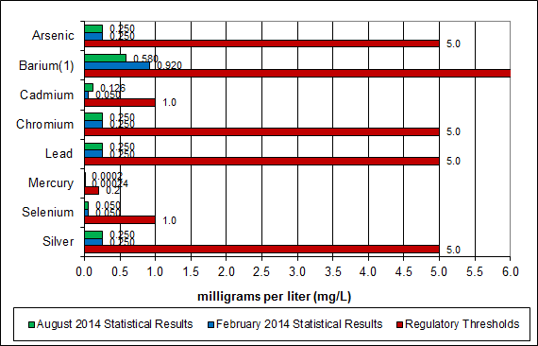

**Note: The regulatory threshold for Barium is 100 mg/L**

CAAI also samples ash monthly in-house, and documents pH reading to adjust dolomitic lime feed rate. The results for the ash pH tests are found below in Chart 16 where each quarter is represented by the average of the respective monthly readings. During Q1FY15, the average ash pH for in-house tests was 10.1.

Chart 16: Quarterly Ash Test Results

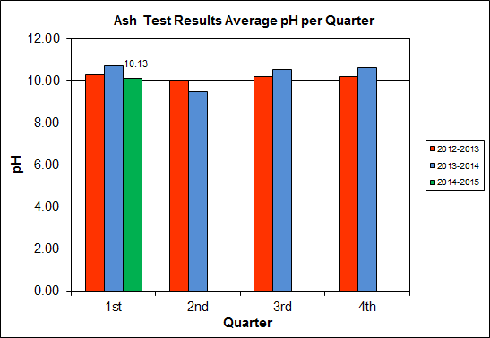

APPENDIX A  
FACILITY CEMS DATA

Table 10: Unit #1 Monthly Summary for Reportable Emissions Data

|  |  |  |  |  |  |  |  |  |  |  |
| --- | --- | --- | --- | --- | --- | --- | --- | --- | --- | --- |
| **Group#-Channel#** | | **G8-C35** | **G8-C28** | **G8-C8** | **G8-C4** | **G8-C12** | **G8-C34** | **G8-C37** | **G8-C40** | **G8-C39** |
| **Long Descrip.** | | **U-1 Steam** | **U-1 Econ** | **U-1 Stack** | **U-1 Stack** | **U-1 Stack** | **U-1 Opaci** | **U-1 FF In** | **U-1 Carbo** | **U-1 Lime** |
| **Short Descrip.** | | **SteamFl** | **SO2ec** | **SO2sc** | **COsc** | **NOxsc** | **Opacity** | **FF InTemp** | **CarbInj** | **LimeFlow** |
| **Units** | | **K#/Hr** | **ppmc** | **ppm** | **ppmc** | **ppmc** | **%** | **deg F** | **#/hr** | **gpm** |
| **Range** | | **0-100** | **0-2000** | **0-500** | **0-4000** | **0-1000** | **0-100** | **100-500** | **0-50** | **0-20** |
| Jul-14 | AVG | 85.2 | 28.0 | 1.0 | 34.0 | 168.0 | 0.6 | 302.0 | 16.7 | 3.0 |
| Max | 88.8 | 47.0 | 3.0 | 46.0 | 184.0 | 1.0 | 306.0 | 18.2 | 3.3 |
| Min | 76.3 | 15.0 | 0.0 | 25.0 | 163.0 | 0.2 | 301.0 | 16.2 | 2.8 |
| Aug-14 | AVG | 83.2 | 22.0 | 1.0 | 33.0 | 165.0 | 0.6 | 302.0 | 16.2 | 3.0 |
| Max | 86.7 | 34.0 | 4.0 | 44.0 | 174.0 | 1.3 | 306.0 | 16.3 | 3.5 |
| Min | 71.8 | 11.0 | 0.0 | 24.0 | 161.0 | 0.2 | 302.0 | 16.1 | 2.6 |
| Sep-14 | AVG | 77.9 | 35.0 | 1.0 | 28.0 | 170.0 | 0.6 | 302.0 | 16.3 | 3.0 |
| Max | 84.9 | 71.0 | 4.0 | 42.0 | 188.0 | 0.9 | 304.0 | 16.7 | 3.1 |
| Min | 66.1 | 11.0 | 0.0 | 14.0 | 164.0 | 0.2 | 302.0 | 16.2 | 2.8 |
| **Quarter Average** | | 82.1 | 28.3 | 1.0 | 31.7 | 167.7 | 0.6 | 302.0 | 16.4 | 3.0 |
| **Quarter Max Value** | | 88.8 | 71.0 | 4.0 | 46.0 | 188.0 | 1.3 | 306.0 | 18.2 | 3.5 |
| **Quarter Min Value** | | 66.1 | 11.0 | 0.0 | 14.0 | 161.0 | 0.2 | 301.0 | 16.1 | 2.6 |
| **Limits:** | | 98 | NA | 29 | 100 | 205 | 10 | 333 | 16(a) |  |

(a) Carbon flow limit is a minimum value

* Note: The data reported herein represent 24 hour average data for all parameters. Emissions excursions that are measured on shorter time intervals (ie., 4-hour block averages for CO) do not correlate with the 24 hour average data reported above.

Table 11: Unit #2 Monthly Summary for Reportable Emissions Data

|  |  |  |  |  |  |  |  |  |  |  |
| --- | --- | --- | --- | --- | --- | --- | --- | --- | --- | --- |
| **Group#-Channel#** | | **G8-C35** | **G8-C28** | **G8-C8** | **G8-C4** | **G8-C12** | **G8-C34** | **G8-C37** | **G8-C40** | **G8-C39** |
| **Long Descrip.** | | **U-2 Steam** | **U-2 Econ** | **U-2 Stack** | **U-2 Stack** | **U-2 Stack** | **U-2 Opaci** | **U-2 FF In** | **U-2 Carbo** | **U-2 Lime** |
| **Short Descrip.** | | **SteamFl** | **SO2ec** | **SO2sc** | **COsc** | **NOxsc** | **Opacity** | **FF InTemp** | **CarbInj** | **LimeFlow** |
| **Units** | | **K#/Hr** | **ppmc** | **ppm** | **ppmc** | **ppmc** | **%** | **deg F** | **#/hr** | **gpm** |
| **Range** | | **0-100** | **0-2000** | **0-500** | **0-4000** | **0-1000** | **0-100** | **100-500** | **0-50** | **0-20** |
| Jul-14 | AVG | 90.5 | 40.0 | 1.0 | 34.0 | 160.0 | 0.0 | 297.0 | 16.3 | 3.0 |
| Max | 92.3 | 52.0 | 4.0 | 40.0 | 178.0 | 0.0 | 298.0 | 16.5 | 3.2 |
| Min | 88.7 | 29.0 | 0.0 | 26.0 | 158.0 | 0.0 | 296.0 | 16.1 | 2.7 |
| Aug-14 | AVG | 87.6 | 30.0 | 1.0 | 36.0 | 159.0 | 0.0 | 297.0 | 16.2 | 2.9 |
| Max | 91.9 | 38.0 | 5.0 | 43.0 | 164.0 | 0.3 | 297.0 | 16.7 | 3.1 |
| Min | 73.4 | 18.0 | 0.0 | 28.0 | 143.0 | 0.0 | 293.0 | 16.1 | 2.3 |
| Sep-14 | AVG | 87.1 | 25.0 | 2.0 | 38.0 | 159.0 | 0.0 | 297.0 | 16.2 | 2.9 |
| Max | 92.4 | 38.0 | 4.0 | 51.0 | 160.0 | 0.2 | 298.0 | 16.3 | 3.2 |
| Min | 75.2 | 11.0 | 1.0 | 28.0 | 157.0 | 0.0 | 296.0 | 16.2 | 2.7 |
| **Quarter Average** | | 88.4 | 31.7 | 1.3 | 36.0 | 159.3 | 0.0 | 297.0 | 16.2 | 2.9 |
| **Quarter Max Value** | | 92.4 | 52.0 | 5.0 | 51.0 | 178.0 | 0.3 | 298.0 | 16.7 | 3.2 |
| **Quarter Min Value** | | 73.4 | 11.0 | 0.0 | 26.0 | 143.0 | 0.0 | 293.0 | 16.1 | 2.3 |
| **Limits:** | | 96 | NA | 29 | 100 | 205 | 10 | 330 | 16(a) |  |

(a) Carbon flow limit is a minimum value

* Note: The data reported herein represent 24 hour average data for all parameters. Emissions excursions that are measured on shorter time intervals (ie., 4-hour block averages for CO) do not correlate with the 24 hour average data reported above.

Table 12: Unit #3 Monthly Summary for Reportable Emissions Data

|  |  |  |  |  |  |  |  |  |  |  |
| --- | --- | --- | --- | --- | --- | --- | --- | --- | --- | --- |
| **Group#-Channel#** | | **G8-C35** | **G8-C28** | **G8-C8** | **G8-C4** | **G8-C12** | **G8-C34** | **G8-C37** | **G8-C40** | **G8-C39** |
| **Long Descrip.** | | **U-3 Steam** | **U-3 Econ** | **U-3 Stack** | **U-3 Stack** | **U-3 Stack** | **U-3 Opaci** | **U-3 FF In** | **U-3 Carbo** | **U-3 Lime** |
| **Short Descrip.** | | **SteamFl** | **SO2ec** | **SO2sc** | **COsc** | **NOxsc** | **Opacity** | **FF InTemp** | **CarbInj** | **LimeFlow** |
| **Units** | | **K#/Hr** | **ppmc** | **ppm** | **ppmc** | **ppmc** | **%** | **deg F** | **#/hr** | **gpm** |
| **Range** | | **0-100** | **0-2000** | **0-500** | **0-4000** | **0-1000** | **0-100** | **100-500** | **0-50** | **0-20** |
| Jul-14 | AVG | 89.9 | 27.0 | 1.0 | 30.0 | 161.0 | 0.0 | 303.0 | 16.3 | 3.1 |
| Max | 92.1 | 45.0 | 4.0 | 35.0 | 179.0 | 0.1 | 306.0 | 17.0 | 3.4 |
| Min | 87.2 | 20.0 | 0.0 | 22.0 | 159.0 | 0.0 | 302.0 | 16.1 | 2.9 |
| Aug-14 | AVG | 83.9 | 50.0 | 1.0 | 26.0 | 161.0 | 0.0 | 302.0 | 16.4 | 3.1 |
| Max | 92.7 | 102.0 | 5.0 | 40.0 | 183.0 | 0.3 | 303.0 | 18.5 | 3.4 |
| Min | 69.1 | 14.0 | 0.0 | 15.0 | 154.0 | 0.0 | 300.0 | 16.1 | 2.5 |
| Sep-14 | AVG | 86.8 | 49.0 | 1.0 | 24.0 | 160.0 | 0.1 | 303.0 | 16.3 | 3.2 |
| Max | 92.1 | 72.0 | 4.0 | 36.0 | 163.0 | 1.2 | 304.0 | 16.4 | 3.6 |
| Min | 74.6 | 27.0 | 0.0 | 16.0 | 157.0 | 0.0 | 303.0 | 16.2 | 2.9 |
| **Quarter Average** | | 86.9 | 42.0 | 1.0 | 26.7 | 160.7 | 0.0 | 302.7 | 16.3 | 3.1 |
| **Quarter Max Value** | | 92.7 | 102.0 | 5.0 | 40.0 | 183.0 | 1.2 | 306.0 | 18.5 | 3.6 |
| **Quarter Min Value** | | 69.1 | 14.0 | 0.0 | 15.0 | 154.0 | 0.0 | 300.0 | 16.1 | 2.5 |
| **Limits:** | | 98 | NA | 29 | 100 | 205 | 10 | 327 | 16(a) |  |

(a) Carbon flow limit is a minimum value

* Note: The data reported herein represent 24 hour average data for all parameters. Emissions excursions that are measured on shorter time intervals (ie., 4-hour block averages for CO) do not correlate with the 24 hour average data reported above.

APPENDIX B  
SITE PHOTOS – AUGUST 2014

|  |  |
| --- | --- |
| C:\Users\kperrin\Desktop\August 2014\P1000877.JPG  Figure 1: Turbine Generator Enclosure Roof Leaking (3 Locations Observed) – New Deficiency | C:\Users\kperrin\Desktop\August 2014\P1000878.JPG  Figure 2: Corrosion on ceiling panels in Turbine Generator Enclosure – New Deficiency |
| C:\Users\kperrin\Desktop\August 2014\P1000879.JPG  Figure 3: Corrosion on ceiling panels in Turbine Generator Enclosure (Alternate Location) | C:\Users\kperrin\Desktop\August 2014\P1000886.JPG  Figure 4: Damaged Tipping Floor wall panels – Rainwater running from outside to inside – New Deficiency |
| C:\Users\kperrin\Desktop\August 2014\P1000887.JPG  Figure 5: Tipping Floor Enclosure roof leaking at truck entrance – New Deficiency | C:\Users\kperrin\Desktop\August 2014\P1000888.JPG  Figure 6: Tire supporting PVC drain pipe at Tipping Floor Entrance – New Deficiency |
| C:\Users\kperrin\Desktop\August 2014\P1000889.JPG  Figure 7: Exterior siding discolored outside Charging Floor louver above Administration Entrance – New Deficiency | C:\Users\kperrin\Desktop\August 2014\P1000867.JPG  Figure 8: New Ash Trailer Canopy – View from SDA Penthouse |
| C:\Users\kperrin\Desktop\August 2014\P1000871.JPG  Figure 9: Dolomitic Lime Silo | **C:\Users\kperrin\Desktop\August 2014\P1000872.JPG**  Figure 10: MSW Pit – View from south end of Charging Floor |
| C:\Users\kperrin\Desktop\August 2014\P1000874.JPG  Figure 11: Turbine Generators | C:\Users\kperrin\Desktop\August 2014\P1000875.JPG  Figure 12: New Ash Trailer Canopy – View from Turbine Generator Deck |
| C:\Users\kperrin\Desktop\August 2014\P1000880.JPG  Figure 13: Firing Aisle – Painting In Progress | C:\Users\kperrin\Desktop\August 2014\P1000881.JPG  Figure 14: Ferrous Magnet – No Issues Observed |
| C:\Users\kperrin\Desktop\August 2014\P1000882.JPG  Figure 15: Main Vibrating Conveyor – No Issues Observed | C:\Users\kperrin\Desktop\August 2014\P1000890.JPG  Figure 16: Ash Load-Out Ramp – No Issues Observed |
| C:\Users\kperrin\Desktop\August 2014\P1000899.JPG  Figure 17: Supplemental Load-Out Dock | C:\Users\kperrin\Desktop\August 2014\P1000902.JPG  Figure 18: Truck Scales – No Issues Observed |
| C:\Users\kperrin\Desktop\August 2014\P1000903.JPG  Figure 19: Entrance road degradation – Citizen’s Drop-off Area | C:\Users\kperrin\Desktop\August 2014\P1000904.JPG  Figure 20: Citizen’s Drop-off Roll-Off |
| C:\Users\kperrin\Desktop\August 2014\P1000905.JPG  Figure 21: General Facility View – View from Southwest Corner of Property | C:\Users\kperrin\Desktop\August 2014\P1000908.JPG  Figure 22: General Facility View – View From Across Eisenhower Avenue |
| C:\Users\kperrin\Desktop\August 2014\P1000892.JPG  Figure 23: General Facility View – View from south side of Cooling Towers | C:\Users\kperrin\Desktop\August 2014\P1000894.JPG  Figure 24: Protective Bollards and Anchor System to New Ash Trailer Canopy |